Requirements to article
For publication in the journal
Applied Business: Issues & Solutions

Title
Antonio Grimaldi ^{1,2*}, Li Li³
1 First affiliation
2 Second affiliation
3 Third affiliation, for example Department of IT, Vilnius Business College, Kalvarijų g. 129-401, LT-08221 Vilnius, Lithuania
∗ Corresponding author, e-mail: xxx.xxx@gmail.com

Abstract. Main ideas representing the behaviour of article. Up to 200 words.
Keywords. Up to 10 words or phrases typical to the subject of article.
JEL index. Please select one or several indexes from [1].

Introduction
These instructions are for preparing an article or review article for publication in the journal Applied Business: Issues & Solutions [2]. Regular article presented in English consist of abstract section, keywords, JEL index, introduction section (unnumbered), two-three-four-five numbered sections of article (according to decision of authors), main results and conclusion section (or Conclusion section, unnumbered), Abbreviation section (unnumbered) and Reference section (unnumbered). If two and more authors are present Authors’ contributions section Conflict of interest section are necessary. Strategic objectives, the problem (up to five enumerated positions) must be formulated in the introduction.
- Name of first section
Regular article could be presented in several formats: *.docx or *.doc (Microsoft Office), *.odt (OpenOffice) or *tex (LaTex). Size of article about 15 pages including tables and charts (Time New Roman font, 12 pt, row interval 1.5). All abbreviations such as IT must be explained in Abbreviation section.
- Name of second section
Citation of references must be provided in numeric style [3]. Soori et al [4] presented a review. For citation of references, doi index in necessary. You can cite the articles in the journals [3,4,5], books [6], chapters in the books [7], conference proceedings [8], internet sites [1,2].
Formulas are allowed following style:
 | Y=ax+by+cz | (1)

Table 1 represents the global analysis of distribution.
Table 1. Global analysis of distribution. Adapted according to Ref. [4,5].
x | y | z | c
10 | 100 | 1000 | 12.5

- Name of third section
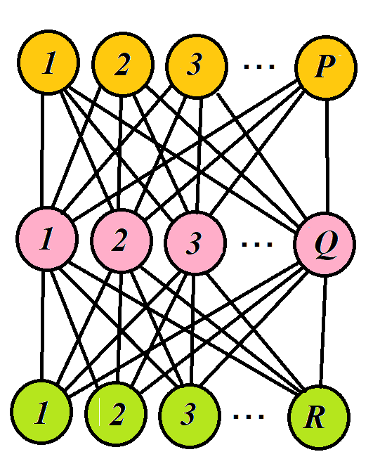 | 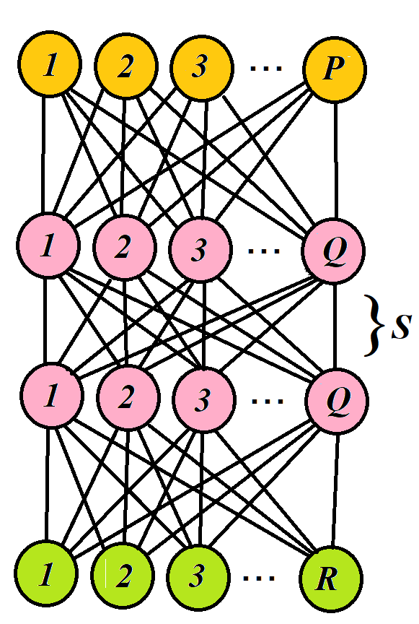
a) | b)
Fig. 1. Feedforward neural networks (FNNs). Hidden layer (red): number of perceptrons Q, input layer (yellow): number of units P, output layer (green): number of units R. Adapted according to Ref. [4]

Fig. 1 represents the Feedforward neural networks (FNNs). All figures must be inserted into text (if available) and attached separately. Format of pictures or charts *.png, resolution 800dpi.

Main results and conclusions (or Conclusions)
The problem that was formulated in the introduction must be stated as a solution (up to five enumerated positions).

Abbreviations
IT - Information Technology
XR - Extended Realities

Acknowledgements
You can acknowledge foundations, scholarships, foundations, organizations, colleges, etc.

Authors’ contributions
Xx developed the methodology, Xx created the final version of article, Xx reviewed the literature, Xx analysed the technologies, Xx highlighted the problem of security, Xx systematized the terminology, Xx experimental word, xx advising and supervising. Xx initiated research concept and design, xx collected and analysed data, Xx wrote the theoretical overview. Xx reviewed the initial manuscript. All authors read and approved the final manuscript.

Conflicts of interest
All authors declare that they have no conflicts of interest (or …).

References
- https://www.aeaweb.org/econlit/jelCodes.php?view=jel, accessed 15-March-2024.
- ABIS, http://www.applied-business-solutions.eu accessed 15-March-2024
- Bekesiene, S.; Smaliukiene, R.; Vaicaitiene, R. (2021) Using Artificial Neural Networks in Predicting the Level of Stress among Military Conscripts - Mathematics 9(2021) 626 - https://doi.org/10.3390/math9060626.
- Soori, M.; Arezoo, B.; Dastres, R. (2023) Artificial Intelligence, Machine Learning and Deep Learning in Advanced Robotics, A Review. - Cognitive Robotics 3(2023)54-70. - https://doi.org/10.1016/j.cogr.2023.04.001.
- Gruodis, A. (2023) Realizations of the Artificial Neural Network for Process Modeling. Overview of Current Implementations. – Applied Business: Issues & Solutions 2(2023)22–27 – ISSN 2783-6967. https://doi.org/10.57005/ab.2023.2.3
- Nejad, A. (2020) Evolutionary Models for Adaptive Artificial Neural Networks in Accounting and Finance Trends. - Academia Eductional, 2020. - Series: Evolutionary Models for Adaptive ANNs - https://doi.org/10.198769124.
- Bartneck, C.; Lütge, C.; Wagner, A.; Welsh, S. (2021) Capter 9 . Application areas of AI. - In: An Introduction to Ethics in Robotics and AI - Springer - https://doi.org/10.1007/978-3-030-51110-4.
- Zhu, Z.; Liu, F.; Chrysos, G.; Locatello, F.; Cevher, V. (2023) Benign Overfitting in Deep Neural Networks under Lazy Training - Proceedings of the 40th International Conference on Machine Learning, Honolulu, Hawaii, USA - PMLR 202, 2023.

